**IFT 166 Introduction to Internet Networking**

**Lab 13**

**Simple network (routers, switches and computers)**

**After you complete each step, put a ‘√’ or ‘x’ in the completed box**

* Objectives: create a simple network with 6 PCs, 2 switches, and a router.
* Identify the proper cable to connect the PCs to the switches. Identify the proper cables to connect a PC and router to each switch. Configure workstation and router IP address information. Test connectivity using the Ping command.

1. Setup the following topology (using only straight-through cable and FastEthernet ports).

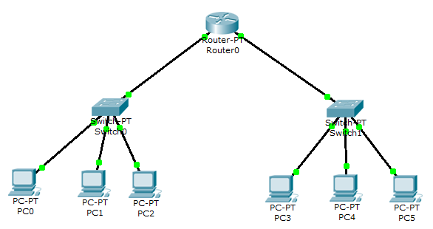

1. Configure the PCs with the following IP address information
2. Include the default gateway as the computers are not directly connected. We essentially have two separate LANs, each connected to its own router.
3. On the LAN with Switch0, we will call this the 192.168.1.0 network
4. On the LAN with Switch1, we will call this the 192.168.2.0 network

|  |  |  |  |
| --- | --- | --- | --- |
| Computer | IP Address | Subnet Mask | Default Gateway |
| PC0 | 192.168.1.2 | 255.255.255.0 | 192.168.1.1 |
| PC1 | 192.168.1.3 | 255.255.255.0 | 192.168.1.1 |
| PC2 | 192.168.1.4 | 255.255.255.0 | 192.168.1.1 |
| PC3 | 192.168.2.2 | 255.255.255.0 | 192.168.2.1 |
| PC4 | 192.168.2.3 | 255.255.255.0 | 192.168.2.1 |
| PC5 | 192.168.2.4 | 255.255.255.0 | 192.168.2.1 |



1. Now will configure the router. Open the router and click the Config tab.
2. On this tab, you can change the Display Name or Hostname of the router (if you want).

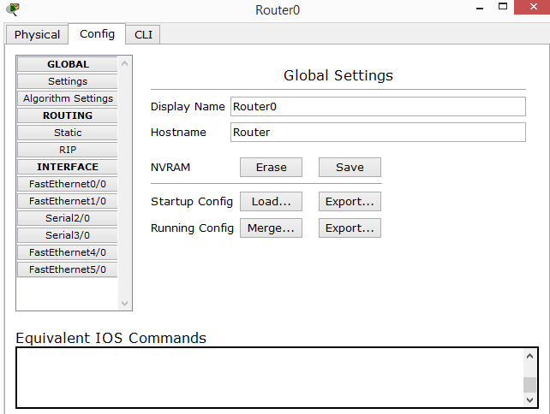

1. Click on the FastEthernet0/0 interface on the left

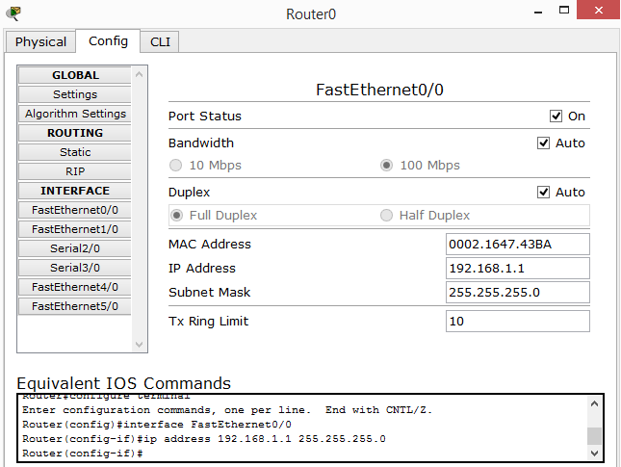



1. Configure the router with the following IP address information

|  |  |  |
| --- | --- | --- |
|  | IP Address | Subnet Mask |
| FastEthernet0/0 | 192.168.1.1 | 255.255.255.0 |
| FastEthernet1/0 | 192.168.2.1 | 255.255.255.0 |

1. Make sure you tick the port status to be ‘on’
2. Carry out the same procedure for FastEthernet1/0 interface
3. From PC0 (on the 192.168.1.0 network) ping PC3 (192.168.2.0 network)
4. Attach a screenshot of your successful ping here!

